McCelvey Mansion
11th & Houston Streets
by Bev Hammett

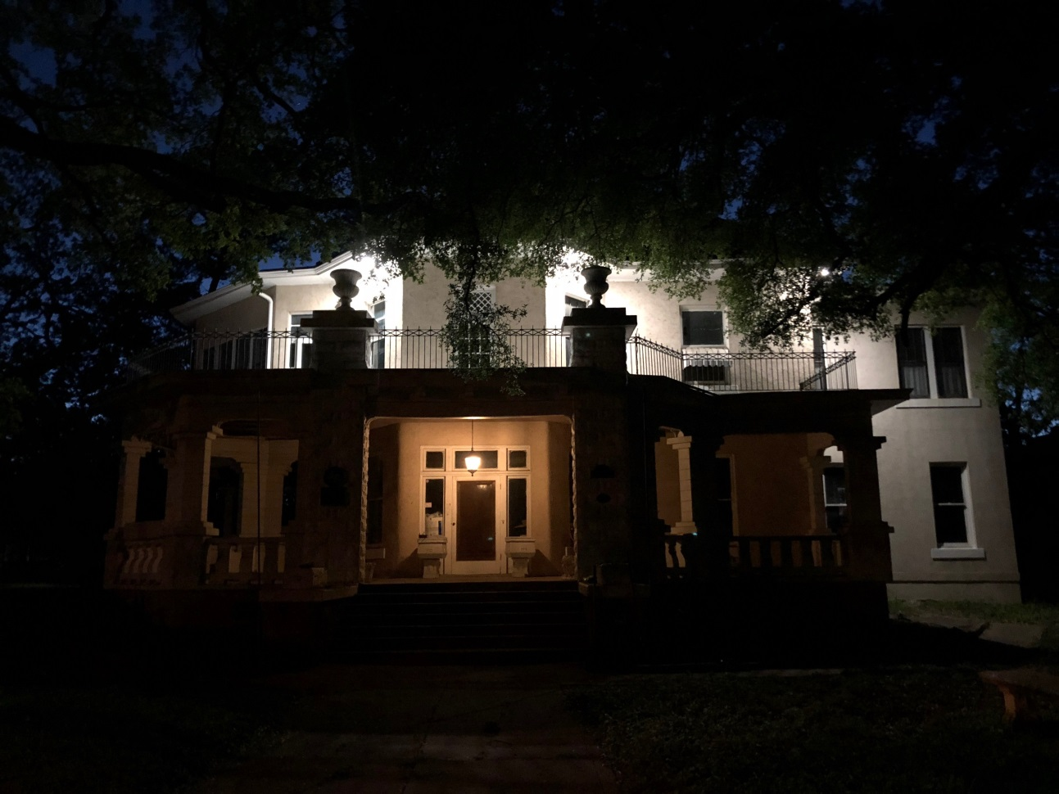

After suffering years of neglect and abuse from renters, this year the historic, McCelvey home was finally put up for auction. The winning bid was awarded to Austin entrepreneur and software consultant Carl von Havighorst, who says he was “just shopping” when he saw the McCelvey Mansion. Even though he has no other historic properties, he knew this home was special, in need of saving.
The “eclectic Gothic” style home was completed in 1906 for Dr. John S. McCelvey and his fiancée, Mary Horne. The house is constructed of concrete blocks cast on the Horne family plantation near Waco. The home has a full attic and basement, in addition to a one-car garage and servant’s quarters.
While Carl has remodeled other properties, he has never undertaken a project of this size so he plans to live onsite while overseeing what could be a lengthy rehab. He laughed, saying "there have been so many curious people walking into my home, I’m finding it difficult to get any work done!"

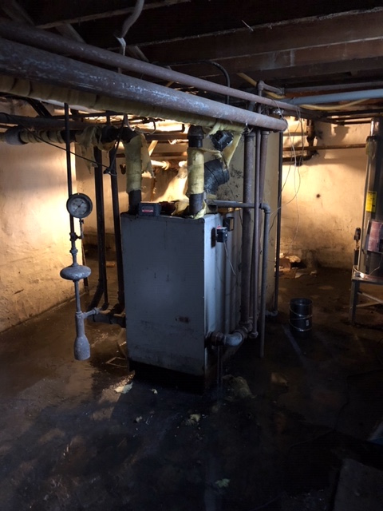

In the basement was an old boiler (above) that was such a safely hazard “no contractor dared light it” so old radiators had to be removed. Upstairs bathroom leaks caused major damage to downstairs walls.

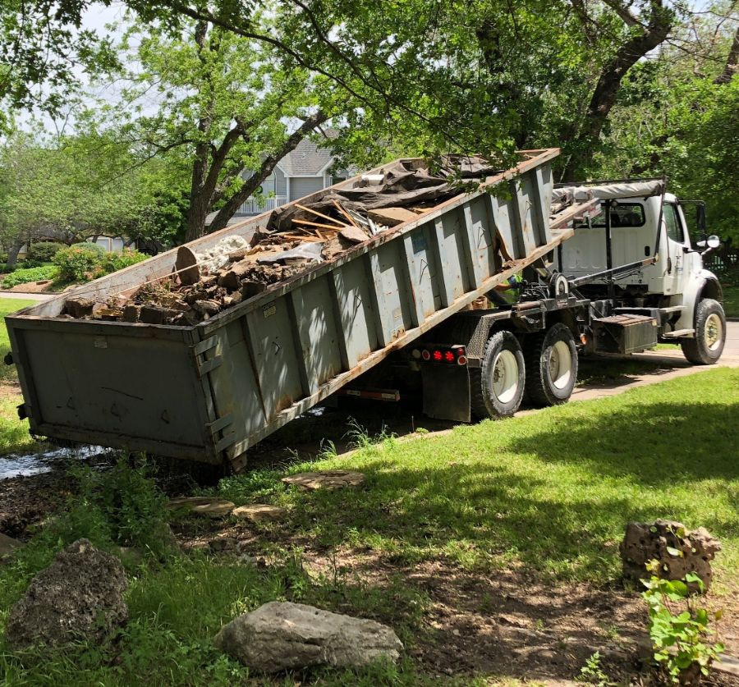

A twenty-yard dumpster was not big enough to remove the demolished bath. Old linoleum was removed from the kitchen (below), the upstairs terrace had to be resurfaced, and the rotted portico ceiling beneath it replaced, as well as sixteen of nineteen windows. Ancient trees overhanging the house had to be carefully trimmed using a “cherry picker."

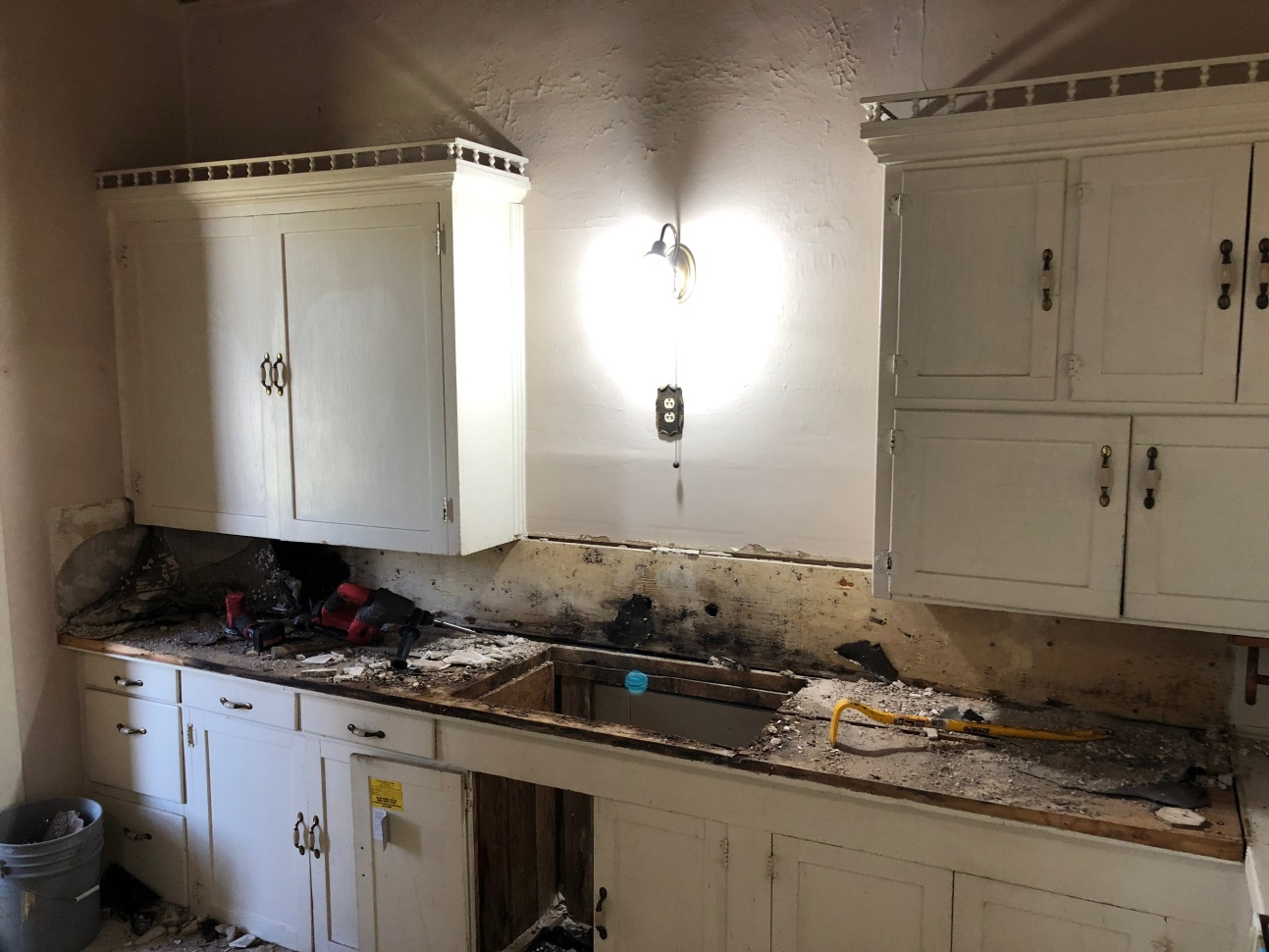

Carl says they’ve found an abundance of wild life sharing the property including tarantulas, scorpions, toads and lizards. But he has also discovered hidden treasures: the overgrown lawn concealed an old patio with a handsome, stone barbecue grill; behind old kitchen cabinetry a giant flour sifter/dispenser was revealed, along with a very large coffee grinder also built into the wall. Rolling away carpet in an upstairs room he discovered a beautiful floor painting of children’s scenes!
He is carefully recording the journey of bringing life back to the once grand residence so we can look forward to seeing his “before” pictures. He knows restoring a home of this size is a bold adventure but he says he wants to keep its integrity and salvage as many of its beautiful old features as possible. On completion, Carl says “the wood floors will look like glass," and after restoration, he has even promised to give the Historic Preservation League members a private tour!
Meanwhile, Carl’s vintage Mercedes looks right a home parked in the driveway.

