OUR NEIGHBORHOOD
Early Life at 618 North 13th Street
by Bonnie Fowler
In 1920, when H.J. Cureton acquired property in North Temple, TX, it was the start of the Roaring Twenties:
- women were given the right to vote
- the American Professional Football League (Later, the National Football League) began
- the first Miss America was crowned
- Babe Ruth was traded to the New York Yankees
- Westinghouse sold the first domestic radio sets in retail stores for $10
- The U.S. Post Office declared that children could not be sent by parcel post.
In 1921, when Babe Ruth hit his 138th homerun, women could buy a fashionably shorter wool skirt for $4.39, men could don a jaunty Fedora hat for $2.98, Agatha Christie published her first novel, The Mysterious Affair introducing her ever-popular detective, “Hercule Poirot,” and Cureton sold his lot to King's Daughter's physician Dr. L.W. Pollok and wife, Kathryn.

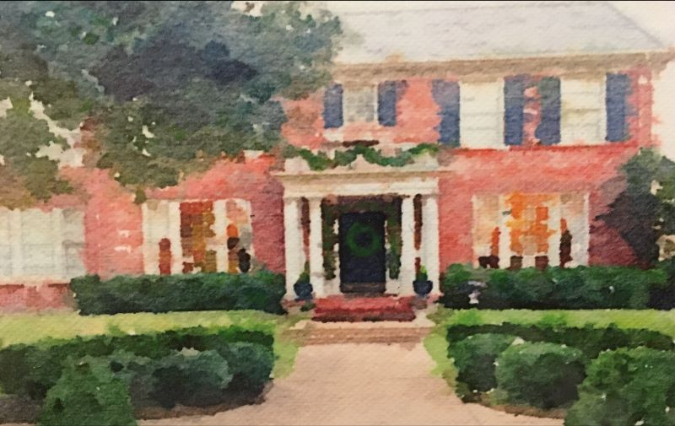

This was not just a piece of land for the Polloks. It’s where they built their home, a beautiful, two-story, red brick house with white columns facing east where they lived with their two children, L.W. Jr., and Kathryn. On the south end were sunrooms, one on each floor. A grand entry with a formal stairway led to the second floor. Tall French doors opened on the left side of the entry into the formal living room. Large windows stretched across the front of this rectangular-shaped room to the opposite wall, where two windows opened into the back yard. Its focal point was the beautiful fireplace on the wall leading into the downstairs sunroom where tall windows on east, south, and west walls spilled sunlight on to red tile flooring. This sunroom also featured a fireplace.

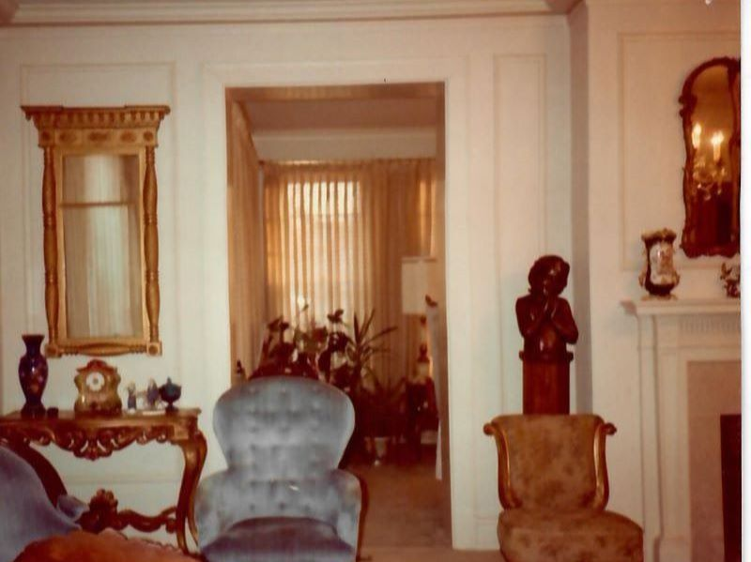
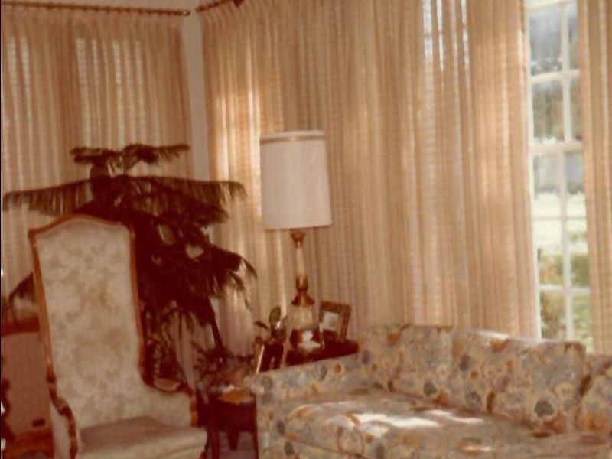

In the foyer across from the living room was a wide doorway into the formal dining room, with a swinging door at the back leading through a butler’s pantry into the kitchen. On the back wall, one doorway led to a basement room used for laundry chores, another into the back yard. Beyond the kitchen was an informal dining area for family meals.
Up the grand staircase, a landing opened on to two bathrooms and rooms above the living room: one across the front/east side of the house, and one on the back/west side of the house, both with doors leading into the upstairs sunroom. Left of the stairwell was a room on the front southeast corner; across the hall was a room over the kitchen and informal dining area.
The Pollocks made one addition to the home when a salesman apparently came through the Northside neighborhood; afterwards, several large homes sprouted identical elevators. The Polloks' elevator was added at the back of the living room on a wall with two windows, the one on the left became the elevator door opening on the second floor above the living room.
Dr. and Mrs. Pollok lived at 618 N. 13th St. until their deaths almost 40 years later when in 1960, their adult children sold the house to A.B. (Moon) and Rosemary Mullins. Moon owned the Temple Furniture Company, a retail business downtown selling fine furniture and carpeting. Their three boys, Mike, Bob, and Pat could walk to school: Mike to the old Temple High School (near the present day post office); Bobby to Lamar, and Pat to Jefferson.
The house needed a lot of updating, and Moon and Rosemary were just the ones to do it. They had the bottom floor sandblasted to remove multiple layers of paint from the walls. Mike says even today, if you rub your hand on the mantle you can probably still feel sand. They opened the wall between the two fireplaces, and added central heat and air.
The sunroom was mid-century modern style, including furniture with a turquoise/teal/blue-green striped sofa and low end tables. To Mike, its mile-long, low-slung sofa made a “very cool room” that impressed his friends.

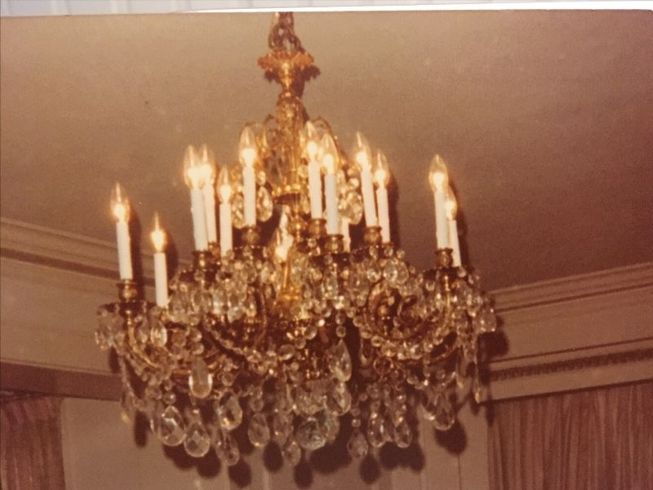

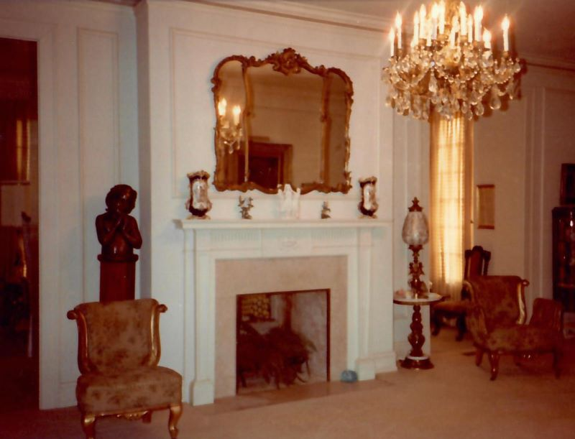
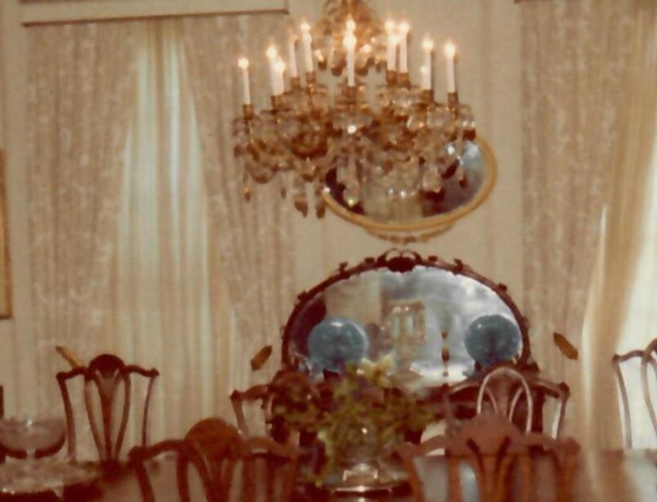

The dining room was outfitted with the cornice boards, new drapes, a traditional dining room table and chairs, and a matching chandelier shipped from Spain. (Neither chandelier is still in the home.) These rooms were rarely used except for special occasions, and the family ate most of their meals in the breakfast room next to the kitchen which explains how the carpets and furniture stayed white in a house with three boys!
The elevator was used only when Great Grandma came to visit, or so the parents thought. Whenever Moon and Rosemary were away, Mike, Bobby, and Pat made use of the elevator, and as Mike explains, “What the parents never knew never hurt them!”
The Mullins used the “special-occasion only” parts of the house for entertaining. Mike recalls resting quietly on the landing floor above the beautiful staircase to hear the adult conversation below. (First children are so clever.)
Upstairs, the front room was the music room, beautifully decorated but seldom used. Next to it, the sunroom became the den, where the family watched TV, hung out together and decorated their Christmas tree. Connecting to the den was the parents’ bedroom; Bobby and Pat had the front corner room, and Mike’s bedroom was in the back.
Beyond the basement laundry room, Moon created a special surprise for Bob, the kid who loved to “tinker” with wood scraps and build things. Asking Bob to go to the basement, Bob figured his Daddy had some work for him but as they passed the laundry area he discovered the next room had been transformed as a woodworking shop, the entire 5’ x 12’ space for his very own. It had a 3’ x 8’ worktable, specially-built drawers for storage, and wall shelving for scrap lumber. Bob said he was the happiest kid alive, not only because he had his own woodworking shop but because his Daddy had recognized his interest and built the shop just for him.
You would think this huge affirmation would turn Bobby into a perfect angel, but Bob found another good use for the basement. When their cousin Julie, a jittery, nervous, easily-frightened girl visited from Fort Worth, Bob urged her to go with him to the basement to see where Dr. Pollok was buried, telling her the doctor had loved this house so much he asked to be interred there. You can already imagine how Cousin Julie was feeling but she went with him, and I think that says something for the girl. Behind a small plywood door in the basement was HVAC ductwork layered on itself resembling a silver coffin. As Julie stood on a step stool to see inside, Bob gave her a push into the small doorway and yelled, “He’s coming out! He’s coming out!” Just like Goldilocks, Julie ran out of that basement and never came back again. Bob said it was one of the best things he ever did! Strangely, Dr. Pollok and his coffin have not been seen since Bob Mullins moved away. Hmmm.
When asked, Pat would say his favorite part of the house was the yard. While he ate and slept indoors, outside is where he spent his time. Mike reports they had a lot of family cook-outs with friends, a hammock, and lush, green grass.
Another favorite spot was the little apartment connected to the garage. Moon turned this space into the “Wildcat Room” for his sons, complete with poker table, and it was fun for the guys to have their own special place to share with friends. They were delirious with excitement when their dad announced he was giving them a colored TV for the Wildcat Room. When the truck arrived to deliver this treasure, the men carefully unloaded and set up a cabinet model TV painted BRIGHT GREEN!! He even had a sign painted for this treasure, “Colored TV.” Needless to say, Moon had the right sense of humor to live with his three sons.

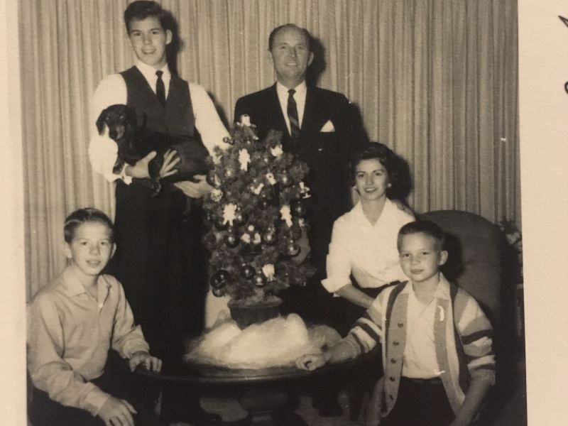

It was a fairytale story:
- boys riding bikes around the neighborhood
- walking to Friday night Wildcat football games (where the middle school field is now)
- walking home for lunch, having a burger and malt at Eckerman’s Malt Shop, eating at the Kyle Hotel Coffee Shop
- Pat jumping out of the Lazy Day Salado Day Camp bus before it stopped and falling into a hackberry bush (which Mike described as something like a cheese grater), Bob punching Mike through the glass shower door and shattering glass everywhere (“Fortunately there were guests in the house, or “Daddy would’ve killed me.”)
- hanging out with friends in the Wildcat Room playing poker and watching "colored" TV, visiting with the Brindleys across the street and Miss Porter, the little piano teacher next door, or Bob and Pat being terrorized by Bridget the dog.
Regrettably, it came to an end. Moon sold his business and moved the family to Atlanta, Georgia for a new job dealing with wholesale furniture. They learned to love Atlanta but were all upset about leaving Temple. Staying only one year they returned, but it was never the same. Instead of moving back to the North Side, they built a new home and Mike left for TCU. But while the idyllic, early days as only the second family to live at beautiful, 618 N. 13th Street were over for the Mullins family, that meant new beginnings for the Sprotts, Chipmans, Kings, and Normans which will be described in the next HPLT newsletter. Thanks to Pat, Bob, and Mike Mullins for talking with me about their adventures.

