618 N. 13th Street 1963-2020
Submitted by Bonnie Fowler-Feb 2020

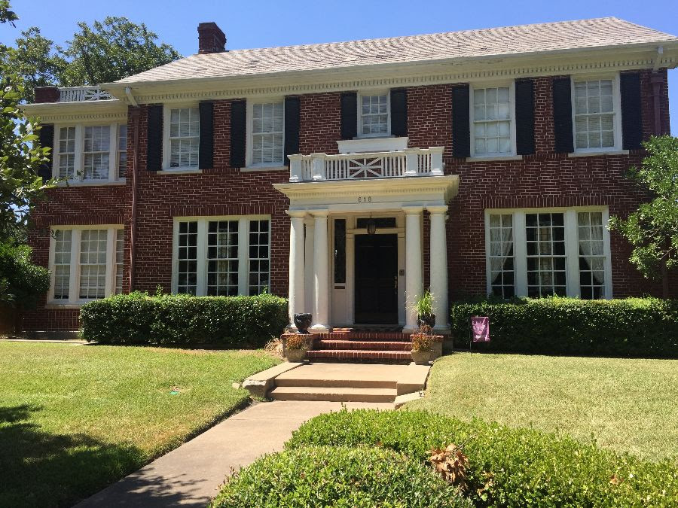

As the Mullins family was moving from 618 N 13th St in 1963, the
number one TV show was “The Beverly Hillbillies”, Liz and Dick topped the movie box office with “Cleopatra”, tickets were $.85, and as the year was winding down, the top song on Billboard Top 100, was “Dominique,” by the Singing Nun. The first push-button land-line phone in the US was installed in Pennsylvania, Studebaker was the first US automaker to offer seat belts as part of the standard equipment on their automobiles, the first class postage stamp was $.05, and the largest corporation in the US was General Motors. An apple was for eating, and you glued google eyes on funny pictures. If you asked for a facebook, you would have probably been handed a book of portraits, and as far as micro and soft, you would never put those two words together. The US military presence in Viet Nam was growing with nearly 16,000 military personnel deployed there, and Civil Rights monopolized the news until November 22, when the world as many of us knew it suddenly changed, and President John F. Kennedy was assassinated on a trip in Dallas, Texas.

Moon and Rosemary Mullins sold the house after living there only 3 years to M. Lloyd Webster, and his wife Phyllis in July, 1963. She died not long after, and he sold the house in November of 1965.

The next to move into 618 N 13th St. was Jack and Jo Nan Sprott. They had two children, Jackie, and Cene’. According to Cene’, her family already lived in the Northside so when this house went on the market, they knew they loved it and wanted it. Lloyd Webster sold the house with all the furniture included.

Jo Nan loved to redo things and decorate, and one of the first things to be done was a bedroom for Cene’. Looking at the front of the house, Cene’ had the upstairs bedroom on the right end of the house. Her mother made it into Cene’s dream room. The canopy bed, the curtains, and the cornice boards were covered to match the bedspread. The carpet was powder blue and white. There was only one tiny closet, so Jo Nan had a wall removed and another closet with drawers and hanging space were added. Cene’ said when it would snow or ice, the trees outside her windows made her room feel like a winter fairyland. This was definitely her favorite room because her mother made it so special for her.

Jo Nan also put her decorator skills to work on the garage which she turned into a game room for Jackie and Cene’. There was a bar for their cold sodas, a pool table, a juke box, and a dance floor. Photos were enlarged, framed in blue and green, and hung on the game room walls. Next to the game room, there was a small apartment with a bathroom complete with a clawfoot tub.

With the kids’ entertainment area provided, the downstairs living areas of the house were reserved for the adults. The floors were covered in white carpet. Jo Nan loved to give parties, and this is where she would host them. Cene’ remembers a grand party her mother gave for Mrs. Brindley, perhaps on her birthday. The sunroom was reserved for Jo Nan, and it is where she would receive guests and just enjoy some time alone. The dining room was used for parties and family dinners on Thanksgiving and Christmas.

Upstairs, the front room was the music room with their piano. The sunroom was used as the family room with the TV. Cene’ tells of watching the moon landing in this room. The parents had the upstairs bedroom where the elevator opened. Brother Jackie had the back bedroom. There was also a laundry shoot which opened into the basement. More than once, Jackie and his friends put Cene’ down the upstairs laundry shoot!

Christmas for the Sprotts meant candles in every window of the house, and a wreath on the beautiful front door. Once again, Jo Nan used her flare for decorating, and flocked the family Christmas tree with her vacuum cleaner. The tree was put into the apartment next to the game room. This is only a guess, but possibly this was to save the beautiful white carpet from Christmas tree needles and white flocking!

In 1969, the Sprotts decided to sell the house and eventually ended up moving to Austin. The house was bought by Charles E. Wesley and his wife Linda E. Wesley. They lived there until 1971 when they sold the house.

The Wayne Chipman family became the beloved owners at that time. Wayne, Louise, Cindy, their only child, and Louise’s mother, Stella Hubbard, moved into 618 N. 13th St in 1971. Wayne died in 1973, at the age of 53 and the home was owned by the Chipman women until Cindy sold it in 1983.

The Chipman family already lived in a home in the Northside, but when it was decided that Mrs. Hubbard would move in with them, they began to look for a larger house. Two houses were considered, but 618 was chosen because it was their idea of a real home. It was also the larger of the two houses.

The front room downstairs was used as the family living room. In the back of the room between the “elevator window” and the real window, there was a large mirror which reflected Cindy’s baby grand piano. As an accomplished musician, she spent many hours practicing and playing in this setting. At Christmas, the tree was in front of the large mirror allowing not only for the actual tree to have center stage, but its reflection also.

The downstairs sunroom was one of her favorite places in the house. There was a stereo and a small portable television there. It was a great place for a teenager to hang out.

The dining room was used for special occasions. One of these occasions was Cindy’s large engagement party. Naturally, the chandelier would be cleaned for this event. As it was cleaned, it was turned and turned to reach all sides, until it unscrewed and fell crashing onto the table shortly before the party. This was an event to remember! For everyday meals, the family ate in the kitchen with a table and chairs in the middle of the room. They thought the breakfast room adjacent to the kitchen felt drafty, and the three women preferred the coziness of the kitchen.

Upstairs on the landing was a large grandfather clock. It was also the place where Cindy’s dad tripped over his beloved Siamese cat one night as they were both going down the stairs, causing Mr. Chipman to fall down several steps.

The bedroom with the elevator door was the guest room. This was Cindy’s second favorite room in the house, and she frequently slept there because it was so peaceful. The elevator was used only for storage.

The back bedroom was Mrs. Hubbard’s room, and she lived there until she and Louise moved to a smaller apartment in 1983.

According to Cindy, the upgrades they did in the house were mostly unseen. They had to replace the plumbing. Her dad did add a small kitchen to the apartment next to the game room. Since there was no garage, they had plans to add a porte-cochere on the right end of the house on Garfield Ave. with a new side entry into the house. This was a plan they never got to.

Cindy always preferred to use the front door to enter the house. When her friends dropped her off at the front, she came in that way. After she got her own car, she parked on Garfield, and came in the front door. When she brought groceries into the house, her mother was embarrassed because “groceries were supposed to be brought into the back door not the front door!”
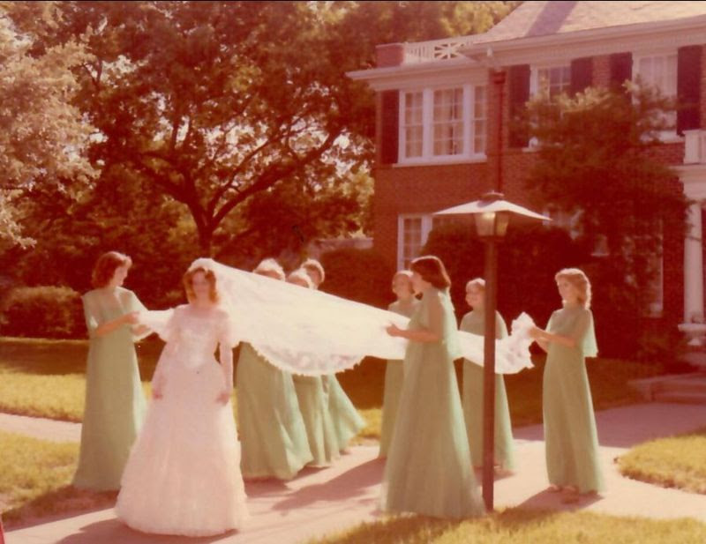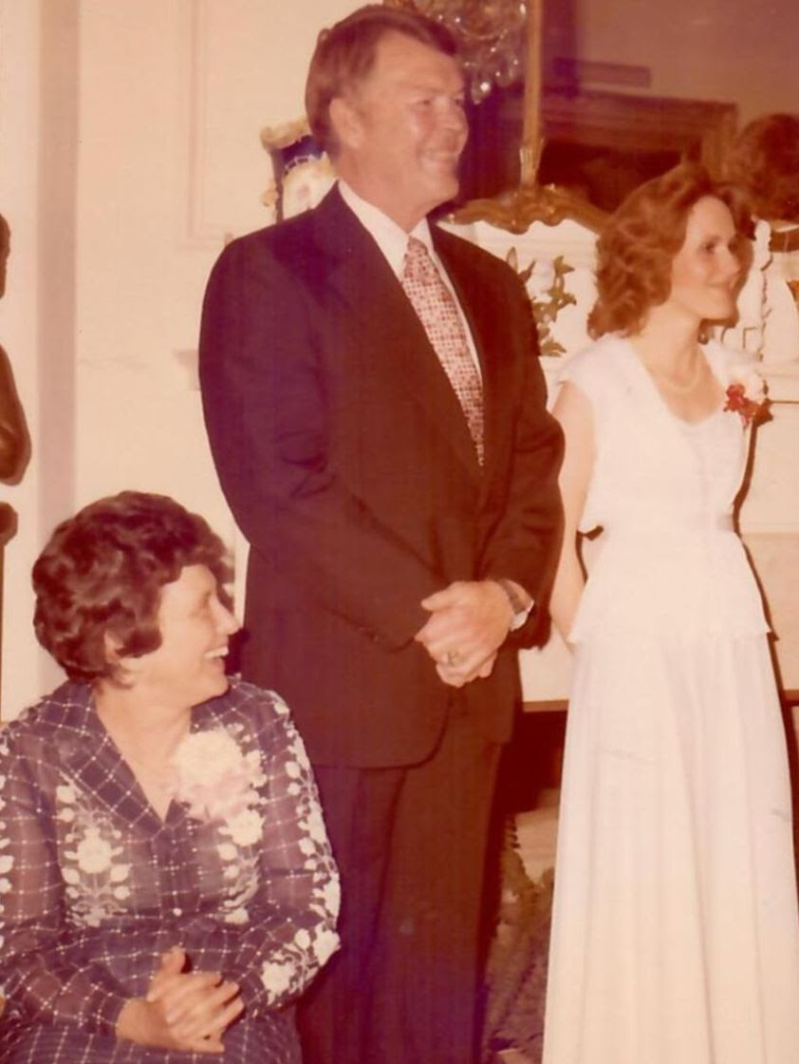

(Above) Cindy’s bridal party-her wedding was hosted at the family home.Cindy with godparents Sammie and Kiefer Marshall; (Below) Cindy, Wayne & Louise Chipman with Stella Hubbard; Cindy

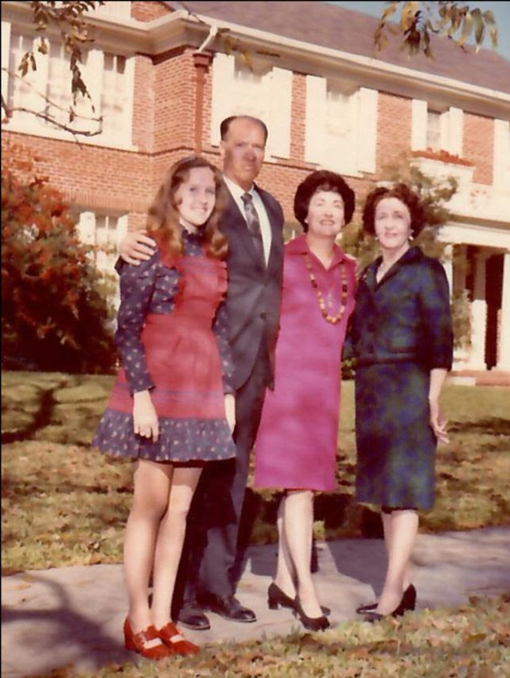

There were so many happy memories at 618 N. 13th St., and Cindy even considered staying there after Louise and Mrs. Hubbard moved, but she sold the house in March of 1983 to Ron and Joan King and began her new life.

What if you were given the option to buy a house in Northside Temple, and renovate it, or build a new house just as you wanted it anywhere you wanted it to be? These were the options Ron King gave to his wife Joan and being in the construction business, she knew he meant it. You might have to think about this, but for Joan, there was no need to think about it. She had grown up in Northside Temple living in the very house her son Stephen and daughter-in-law Whitney live in now. It was her dream to move back to this beautiful area with tall trees, pecans on the ground in autumn, sidewalks, and children’s voices playing with their friends. I met with both Ron and Joan, and I had a wonderful visit while learning about their time in this special house.

Just as Ron promised, he did a complete renovation of the house from top to bottom. The layout for all the rooms remained the same, but when Ron, Joan and their sons Jeffrey, Scott, Carey, and Stephen moved in to 618 N. 13th St., everything was updated.

The front room downstairs was used for the family living room. When asked where they put their Christmas tree, they both agreed that it was always in this room in front of the big windows at the front of the house. The sunroom next to the living room was a cozy sitting area chosen by Joan as her favorite room in the house because it was so bright and sunny.

The dining room was mostly used for holidays and special occasions, because the family ate in the small room at the back of the house next to the kitchen. Eating as a family was an important thing for Ron and Joan, so they reworked schedules to have as many of the family as possible sit down together in the cozy little eating room for a family meal. I asked Joan what the family especially liked for her to fix for them to eat. She said chicken fried steak was the favorite meal, but Captain Crunch for breakfast was a close second!

After they had lived in the house for awhile, Ron remodeled the kitchen. He removed a doorway from the kitchen to the front hall, and put cabinets in that space. A large island was added to the center of the room for counter workspace and storage below.

Upstairs, the master bedroom was the front room over the living room…the one used as a music room by some families. The elevator opened into the room behind this room, and the Kings used it as a study room for the boys and also a guest room when needed. The elevator was not off limits, but generally everyone used the stairs. The boys shared the other two bedrooms.

The upstairs living room was the sunroom. It was a cozy family gathering room when the boys were there. Ron chose this room as his favorite room because his favorite chair was there, and this is where he would watch TV. He also had a fold-out table where he could lay his construction plans.

The original garage and maid’s quarters which had been turned into a kid’s entertaining area and a small apartment became another of Ron’s remodeling projects. He turned all of this into an apartment for his mother who lived there for three years, before moving to Houston to be near her daughter. Temporarily this space became a game room and pool room again until Joan turned it all into an office for her appraisal business.

At one time, the boys built a skateboard ramp in the backyard. The sounds of the skateboards on the ramp and of all the boys who congregated in the King’s backyard was so loud that Joan felt the need to speak with the neighbors about the noise. The neighbors assured her that they loved the sounds of the kids having a good time. No more concerns about noise. Let the boys enjoy themselves, and they did!

While the boys were enjoying the skateboard ramp, Ron was making his own kind of noise in the back. The noise of construction was going on as part of the backyard was becoming a new garage. In addition to the garage, there was storage, an open porch, a kitchenette and full bathroom. Much of the grassy area was covered with brick making the backyard one large patio…with a skateboard ramp!

Each year the Kings lived at 618 N 13th St, they gave a Christmas Eve party. It originated as a Christmas event for the older people in the neighborhood. There were many people whose children had grown up and moved away and several widows who still lived in the Northside Temple. Joan’s parents had done something similar to this for the older ladies who lived near them. The Kings carried on the tradition with their boys delighting the older neighbors by walking them to the party, or driving them when they were old enough to have a driver’s license. Over the years the party grew into a much larger neighborhood-and-beyond event.

One year a young couple appeared at the party and stayed the full time. None of the family knew them. As people were leaving, Ron and Joan spoke with the mystery guests and learned the couple knew Joan’s cousin in Austin. When her cousin heard the couple was moving to Temple, she told them about the King’s Christmas Eve party, how great it was, and suggested they should go. They did! Mystery solved!

After twenty-three years, Ron and Joan decided to sell their home. They were spending a lot of time at the beach for getaways and could not give the 618 house the attention it needed. They sold it the first day it went up for sale, built a new home on some wonderful property Joan had found, and began a new life for themselves!

The Michael and Brittany Norman family moved into the home in May of 2004. They had lived in San Antonio, where Brittany was from, but planned a move to Temple where Michael had grown up. Having lived in a wonderful house in a historic neighborhood in San Antonio, Brittany knew this was what they wanted in Temple. One day she received a call from her father-in-law about a house that had just been listed for sale. She immediately drove to Temple, toured the house with her in-laws, and wrote a contract that night. It was the right house, and the backyard sealed the deal. The large yard made into a brick patio would be perfect for their family.

This family of seven has used the four main upstairs rooms as bedrooms, and every child has shared a room at some time. All five kids have shared one bathroom. Brittany said it was good practice for college and for life!

The downstairs is used as the family living and entertaining space. The living room is truly lived in by all members of the family. The two sofas facing each other on either side of the fireplace are in constant use as a place to rest, do homework, visit with friends, or work on the current puzzle on the coffee table. The sunroom adjacent to the living room is the family television hang-out space.

With seven people in this family and frequent guests for meals, the dining room is used on a daily basis. This is their primary eating space, so whether there are two or fourteen, the dining room is where they eat. Sometimes they add more tables in the entry hall and the living room to have space for everyone who is there. Since they screened in the porch at the back of the garage, they eat a lot of meals there when the weather is good. Family meals are very important, “So even with busy school schedules, we modify our dinnertime to gather as many of us as possible each night,” said Brittany.

Since moving in, the kitchen has changed very little. Except for adding cabinets all the way to the ceiling, it is the same. The room next to the kitchen has had more changes than any room in the house. It has been an office, a playroom, a kennel room for the dogs, a study room, and briefly an eating room. Regardless of what it looks like or what furniture is in it, this is a room for studying, sitting, reading, and for the two giant dogs who have a love/hate for watching the squirrels from the windows!

This is an important place for the Norman family. It has served as a gathering spot for many family celebrations and special events, lots of church and community events, house concerts, dinners, around-the-table conversations, and a special place for family and friends.

From 1921 until 2020, almost 100 years, eight families have called 618 N 13th St. home. The rooms have changed uses to meet the needs of each family, but basically there have been no real changes to the house. I was able to reach five of these families to hear their story, and each of them expressed a love for living here… for the house itself, and for being able to have their life experiences in such a special place. Here’s to 100 more years!

