517 North 9th Street
by Heather Schoenborn

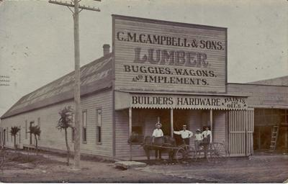

Colonel Cyrus Maxwell Campbell moved to Bell County in 1883 along with his wife, Lydia Anne Dever Campbell. He founded the C.M. Campbell & Sons Lumber Company at 103-111 E. Avenue A in Temple, TX.

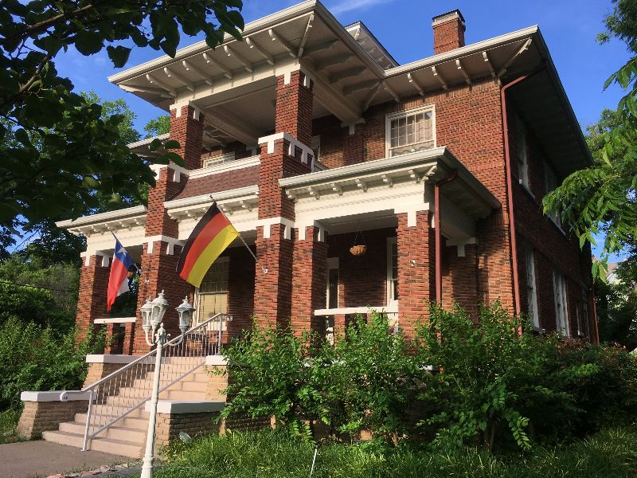

Years later their youngest son, Roy R. Campbell, took over the family business and in 1912, built a home at the corner of North 9th and French, shortly after the passing of his mother. Despite speculation from the general community, the home was not built for a new bride, but for himself and his aging, widowed father.
But four years later on a Monday morning in February when teacher Pearl Paul did not appear at school, townsfolk were surprised to discover news of Sunday afternoon nuptials.

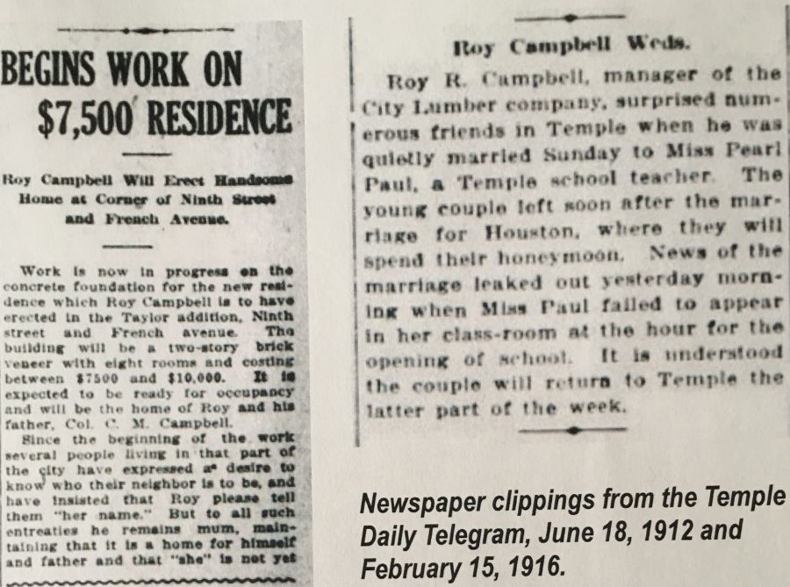

Despite being new in town, the evidently mysterious Mrs. Pearl Campbell was welcomed warmly, as announced in the society column of the Temple Daily Telegram: “Not for many seasons has society been so keenly interested as in the presentation of Mrs. Roy Robert Campbell…Mrs. Campbell is practically a stranger in Temple and having become the bride of one of the most prominent of the city’s young men, it was but natural that invitations announcing her presentation would be received with pleasure.” Hundreds of visitors came to the reception to pay call, and she was reported to be “piquant” in turquoise taffeta! “Thus, with all that society sanctions, there was acclaimed the welcome of Mrs. Roy Robert Campbell among the friends who have long been her husband’s friends, who came to the number of three hundred or more to give the warm handclasp and make the bonny young woman feel that a place all her own was in waiting for her.”

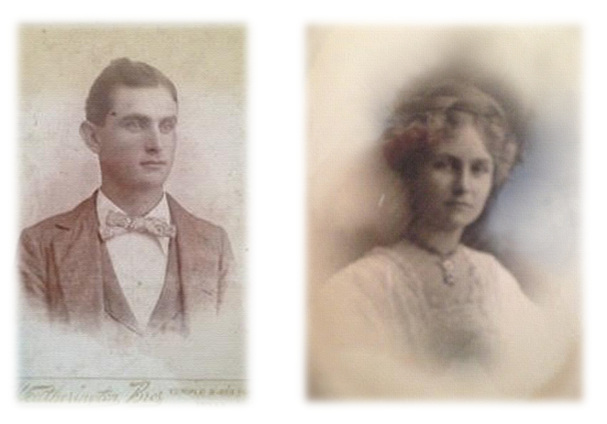

Roy & Pearl Campbell

Five Campbell children were born in their home, three of whom lived to adulthood. The Campbell's first children were twins, a brother and a sister who were unfortunately stillborn on October 8, 1916. In 1919, daughter Lucile Campbell was born followed shortly by her sister, Anne.

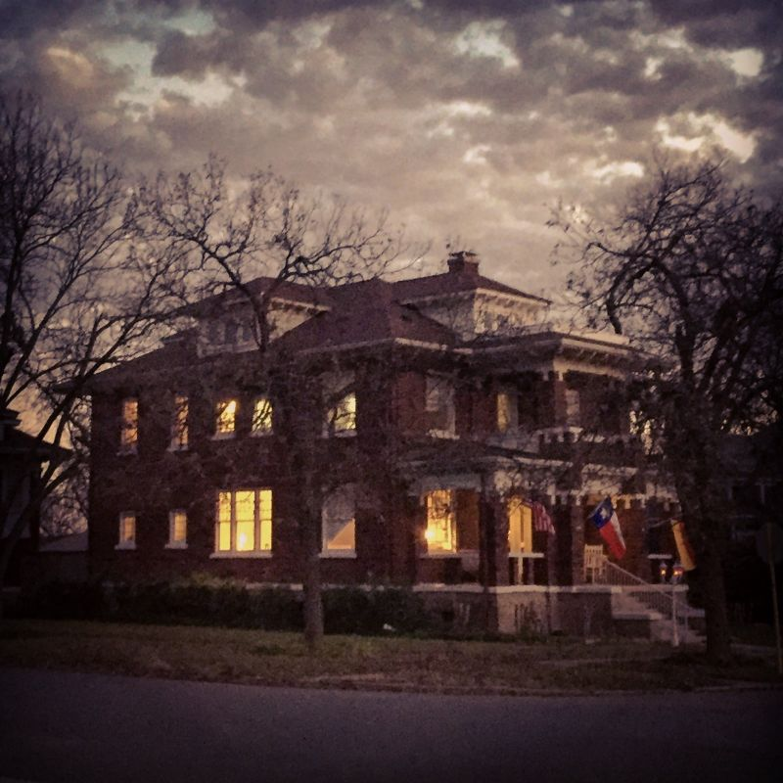

In their grand home, three generations lived happily together. Leading “a sedate and calmer existence, happy in the society of his children and grandchildren and finding his greatest pleasure in their happiness,” Col. C.M. Campbell spent his final years there. His passing in 1921 was a momentous occasion in Temple, when local banks closed for the day to accommodate his funeral.
Four years later in 1925, Roy Jr. was born. The Campbells moved to San Antonio to better manage the family lumber business, which had opened a second office there in 1908. The Temple location eventually closed, but Roy Campbell, Sr. continued to run Campbell Lumber and it has remained in operation in San Antonio for more than 100 years, passed down to Roy Campbell, Jr., then Roy Campbell III, and finally to William Campbell in the present day.
Roy Campbell lived until 1952 and died at the age of 76. Pearl lived until 1970, when she died at the age of 78. Both Roy and Pearl were laid to rest in Temple, in Hillcrest Cemetery.
In 2018, Heather and Lukas Schoenborn bought the property as their first home together, and the house welcomed another first baby - their daughter Elsa - this past September. They are thrilled to claim the honor of ongoing stewardship for this stately home, and are dedicated to preserving both its beauty and intriguing history.

